GOGG NEWSLETTER MARCH 2021

The Grumpy Gardener in Winter
Winter’s not a bad time for the grumpy gardener as short days and bad weather give a great excuse for avoiding the garden during the cold, dark months.
Of course, in summer the grumpy gardener can spend time sitting in the sun sipping an ice cold beer or dry white wine just watching the flowers grow but there are jobs that must be done so it’s not all wine and roses. In winter, however, there aren’t really too many jobs that can’t wait until the spring if one prefers. There are jobs that keen gardeners will want to be getting on with whatever the weather but, at this time of year, I’m quite happy to stand at the kitchen window just looking at the garden and watching the birds. I could, I suppose, cut down the stems of the perennial plants that flowered in late summer such as golden rod and Michaelmas daisies but as wildlife gardeners we need to leave the seed heads for the birds to feed on. Similarly, we could dig over the veg. beds but as we’re “no-dig” gardeners that’s not on. We can happily delay the job of spreading compost over the veg beds until we’re ready to plant up the beds.
I do actually venture out into the garden during winter in order to fill up the bird feeders and take our kitchen waste down to the compost bins when it’s not actually raining. However, as January nears its end fine days give the first glimpses of spring approaching and going into the garden becomes more and more interesting and enjoyable. First the primroses begin to flower, followed in late January by snowdrops, then winter aconites and crocuses which seem to pop up almost unseen and now with February on the doorstep the hellebores begin to open up for their long flowering (or really “bracting”) season. Outside the back door I catch the scent of winter box and under the arches the rich smell of the winter honeysuckle fills the air. The robins have been singing all winter but now their songs are becoming more varied and they are being joined by other birds such as great tits, dunnocks and thrushes whenever the weather isn’t too awful. Also, it won’t be long before the local blackbirds join in the chorus!
So there’s no getting away from the fact that with spring in the air even the grumpiest gardener begins to want to get out into the garden to do some of the more enjoyable spring jobs such as pruning the roses, clematis and other shrubs. The more boring jobs such as cutting the grass including the chore of trimming the lawn edges (Why oh why does grass have to grow sideways into the borders?) can probably wait awhile. Yes, there’s no doubt that spring will draw even the grumpiest of gardeners into the garden to enjoy the birds singing, the insects buzzing and to look at the new growth all around thus putting an end to our long, lazy hibernation.

Sp
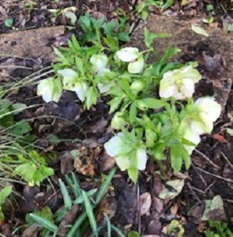
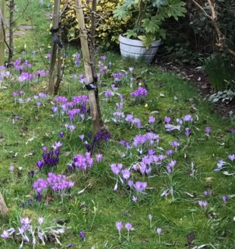
Winter Flowers – Vic & Stella’s Garden

In the snow and caught on their trail camera
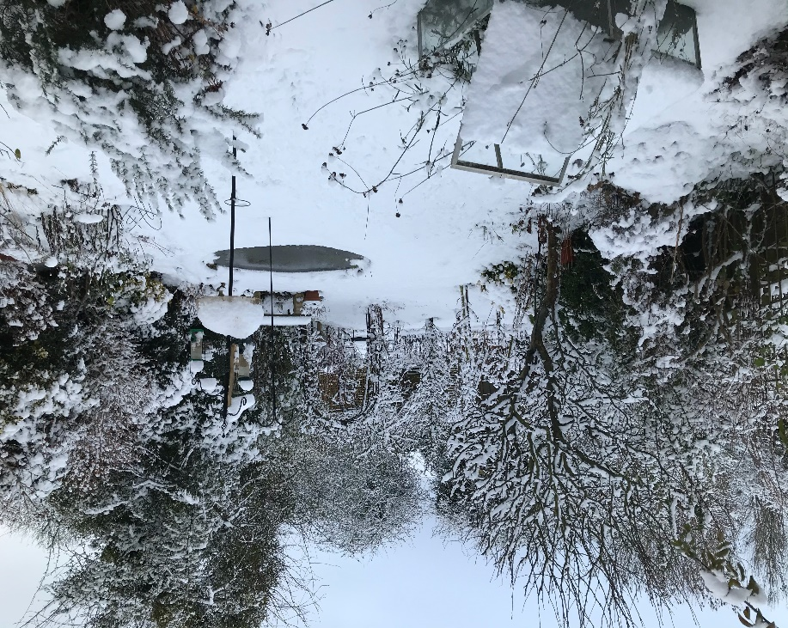
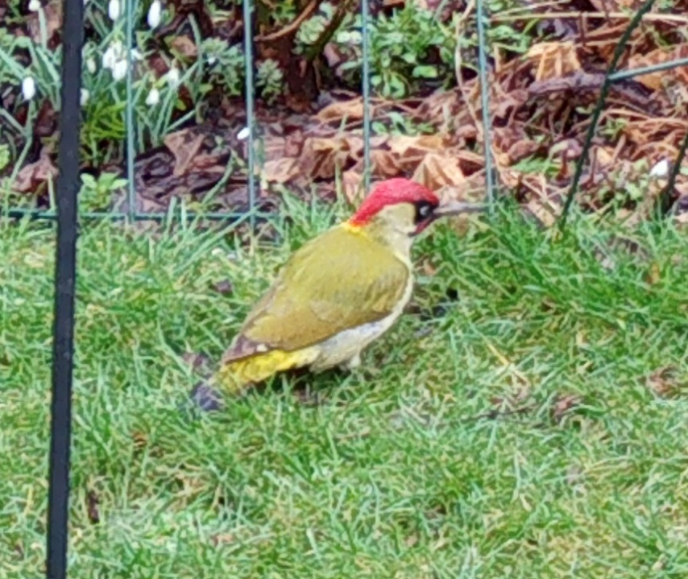

Black Turtle Bean update – Carol Shayle

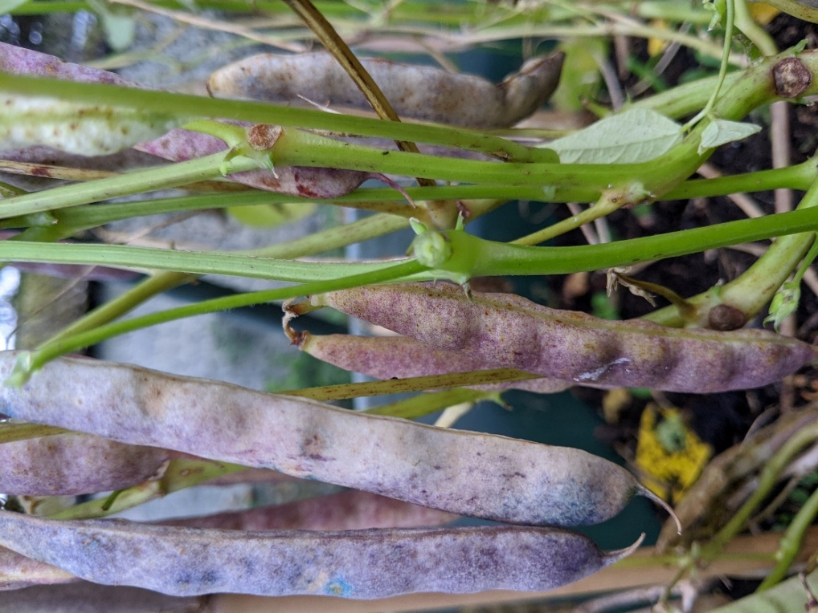
Initially I bought 50grms of dried Black Turtle Beans for £1.10 from Waitrose. I sowed the seeds in a tray and transferred to a large pot. The beans grew well and have now been dried. Next year I will grow them again but I will sow in early April which is earlier than this year. Perhaps the yield will be even higher. I might even try growing other dried beans found in the supermarket.
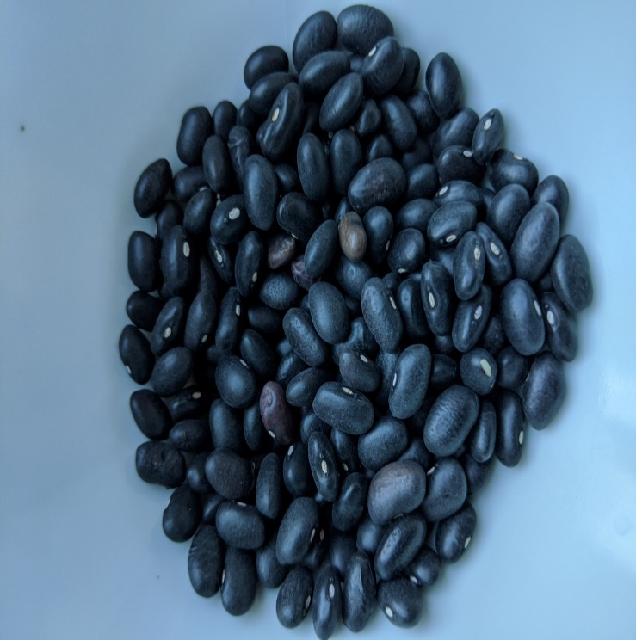

Climate Action and Nature Recovery 2030 - Lesley Greene

Many parish councils in Gloucestershire have signed Climate Emergency declarations. Our Parish Council, Bisley with Lypiatt, signed a Climate Emergency declaration in 2019. In 2020 it started to consider actions it could take as a Parish Council,
simultaneously encouraging an independent Climate Action Group to start up. That group is now up and Zooming – COVID is preventing it ‘running’!
We have a steering committee and four ‘subgroups’, the most popular of which is called “Nature Recovery and Growing”. We are a rural parish with many family farms as well as allotments and keen gardeners. Food systems contribute 21% to 37% of global greenhouse gases, and are significant contributors to deforestation, biodiversity loss and declining water tables. We suspect our food footprint is slightly smaller but need evidence, so we are exploring how large a carbon contributor food growing/agriculture is to the parish. If you do your carbon footprint through familiar tools such as the WWF they pay little heed to food and growing never mind organic growing.
Garden Organic did a members’ survey in 2007 ( https://orgprints.org/18432/) and it found a saving of 13% on the average UK footprint attributable to fruit and vegetables
However according to GO when I asked if they could do another that we could use in our Parish they said “even at the time the people running this experiment realised that it is a large, complicated task, and it is difficult knowing how many assumptions / generalisations you can make and where to draw boundaries “.
GO have considered reviving the garden footprint, as it is so worthwhile and very relevant but they would need extra resources / time / staffing even to reuse the resources that have been drawn up. That is their main barrier to being able to do it right now.
We are fortunate that our group includes supportive and interested farmers. We are also fortunate we have Bisley Community Composting scheme was not only the first independent organisation to ‘sign up’ to the Climate Emergency and led their support but is also pursuing research into its own carbon footprint and carbon sequestration but has been running a peat free campaign since 2014.
I hope ALLAGOG members can persuade their parishes and towns not only to sign up(if they haven’t so far) but to feedback via the members emails , and help in the sharing of experience and knowledge.
I would like to continue sharing our experience with you in regard to organic gardening and food growing with you in this climate emergency journey and hope very much you can contribute your thoughts, inspirations and projects as we go along.
I hope you agree
LG

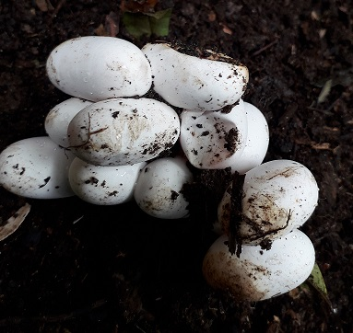
Compost bin – Carol Shayle
During the first lockdown my husband built a couple of new compost bins in the garden. Compost from the old bins was transferred into the new ones. Within days a rabbit had produced five young under the heap; a grass snake had laid ten eggs near the top of the heap and a mouse and a toad had taken up residence. Later the grass snake was seen a couple of times under the carpet on the top. The toad has sensibly vacated the heap and now lives in another part of the garden. I won’t tell you what happened to the rabbits!
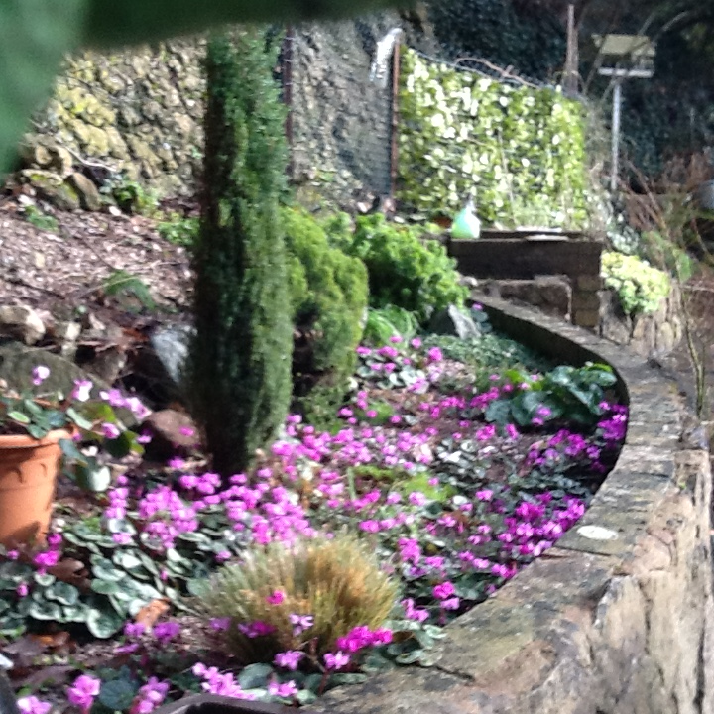
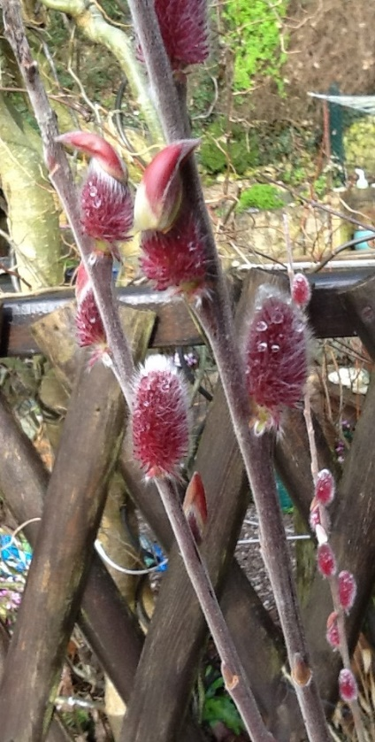
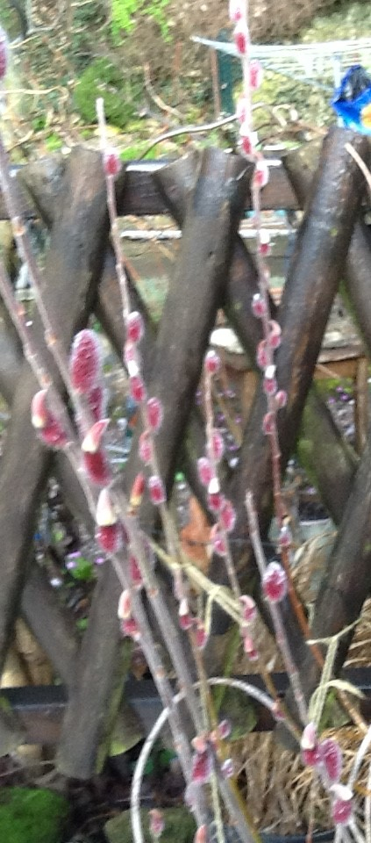
Unita Wood’s garden

Cyclamen Coum Willow Mount Aso

Did you know?
Caffeine, bees & us
Caffeine can be an insecticide, insect repellent & weed killer

Different plants have independently developed the ability to produce caffeine
e.g. Holly
- contains compounds that are used for plant manipulation and mind control
- leaves are toxic, they contain caffeine but are not related to coffee or tea
- the berries contain caffeine.
- it packs weedkiller into its seeds to allow it to kill other plants around it so it may thrive

Why has caffeine developed in flowers?
- One of the many reasons that plants produce caffeine (in their nectar) is as a performance enhancing drug to be able to manipulate bees to do their bidding - pollination.
- Bees get off on caffeine, it improves their memory and ability to find flowers and indicate the location to other bees.

Caffeine also improves learning and memory in humans as our brains are slightly similar to bee brains !
So when we have a cup of coffee, it makes us feel awake, improves memory & mood, that’s because plants are trying to manipulate us, thinking we are bees.
Taken from Nature’s Table podcast featuring James Wong.

Clive’s Christmas Quiz (belatedly)

1 | What tree fruit is never sold in shops  - Medlars b. Quince c .Mulberry
2 | Is Nutmeg a fruit ,seed or nut
3 | Why did King James silk industry collapse  - wrong silkworms b. cold weather c. wrong mulberry
4 | Are fuchsia fruits edible  - yes b. no.
5 | Why do Mexican Beans jump  - Mr Trump b. fright c. Insect
6 | What colour were the original carrots  - green b. purple c. white
7 | What family does Asparagus belong to  - begonia b. dahlia c .lily.
8 | .If you planted a peach stone what could you expect it to grow into  - peach b. nectarine c. either
9 | What is the world’s oldest living tree  - oak .b. spruce c. cherry.
10 | How old is the world’s oldest living tree  - 600 b. 4000 c. 9,500 years old
11 | What ancient tree survived atomic blast in Nagasaki  - Cherry b. magnolia c. ginkgo.
12 | What insect carried the death sentence if you smuggled it out of China  - Flea b. death’s head moth c. silkworm
13 | Who bred the orange carrot  - English b. French c. Dutch
14 | Why did they breed it orange .  - to please royalty b. they did not like original colour  c. it was a mistake.
15 | What colour is the latex(sap) from the rubber tree  - Black b. green c. white.
16 | Do Egyptian tree onions grow in trees  - Yes b. no
17 | Why are Bananas in danger of extinction.  - Deforestation b. monkeys b. rarely set seed
18 | How long have hops been used for brewing.  - since the 9th Century b. 12th century c. 14th century

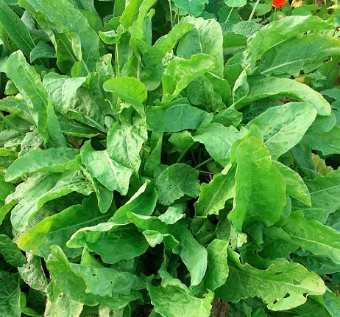
Sorrel
In her talk to us on unusual veg, Sally Cunningham mentioned sorrel as a perennial veg, apparently there is a good variety offered in Garden Organic’s Heritage Seed Library. This is the one that I have and I can harvest from it on most days of the year, for use in salads.
Elaine

Butterfly Quiz answers
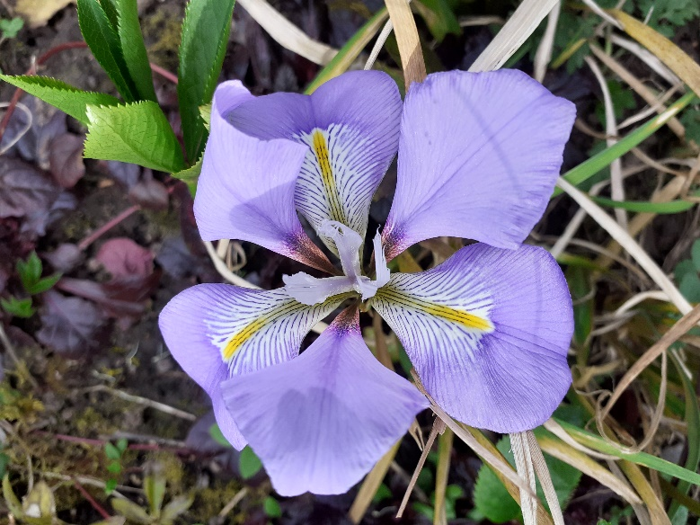
1 | Cabbage Whites | 11 | Duke of Burgundy
2 | Red Admiral | 12 | Ringlet
3 | Painted Lady | 13 | Speckled Wood
4 | Orange Tip | 14 | Comma
5 | Small Skipper | 15 | Purple Emperor
6 | Peacock | 16 | Meadow Brown
7 | Small Blue | 17 | Gatekeeper
8 | Chalk Hill Blue | 18 | Brimstone
9 | Grayling | 19 | Tortoiseshell
10 | Holly Blue | 20 | Adonis Blue
Iris unguicularis
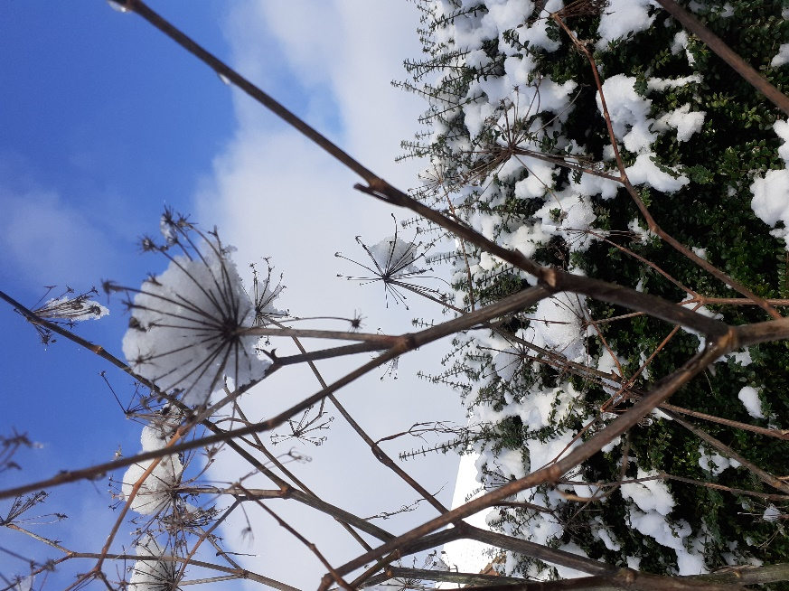
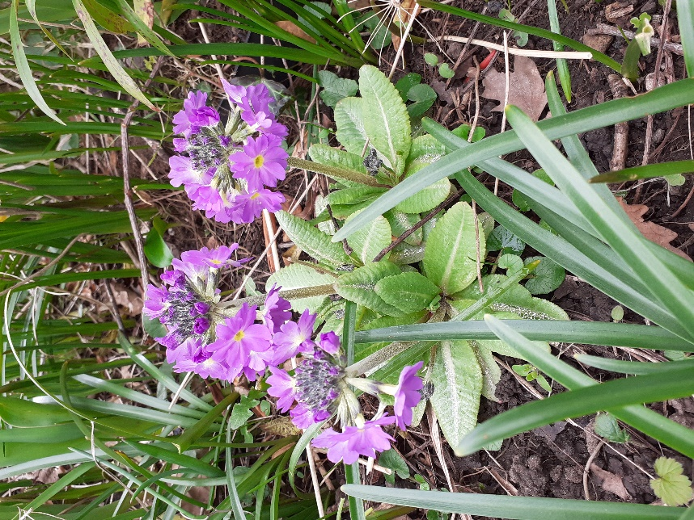

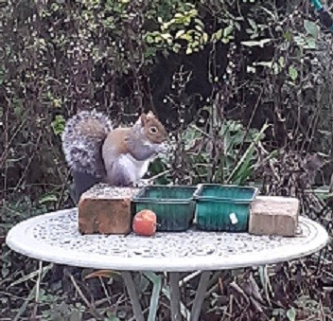
Primula Denticulata Fennel seedheads
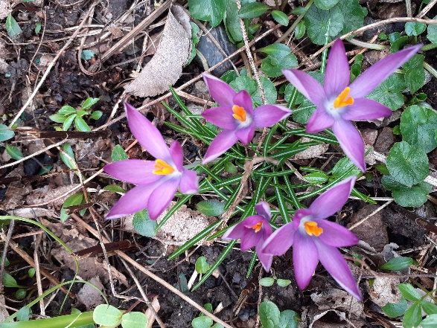
Crocus Thomasinianus Roseus

A new visitor, probably from Highnam Woods!

Sue & Robin’s allotment & garden
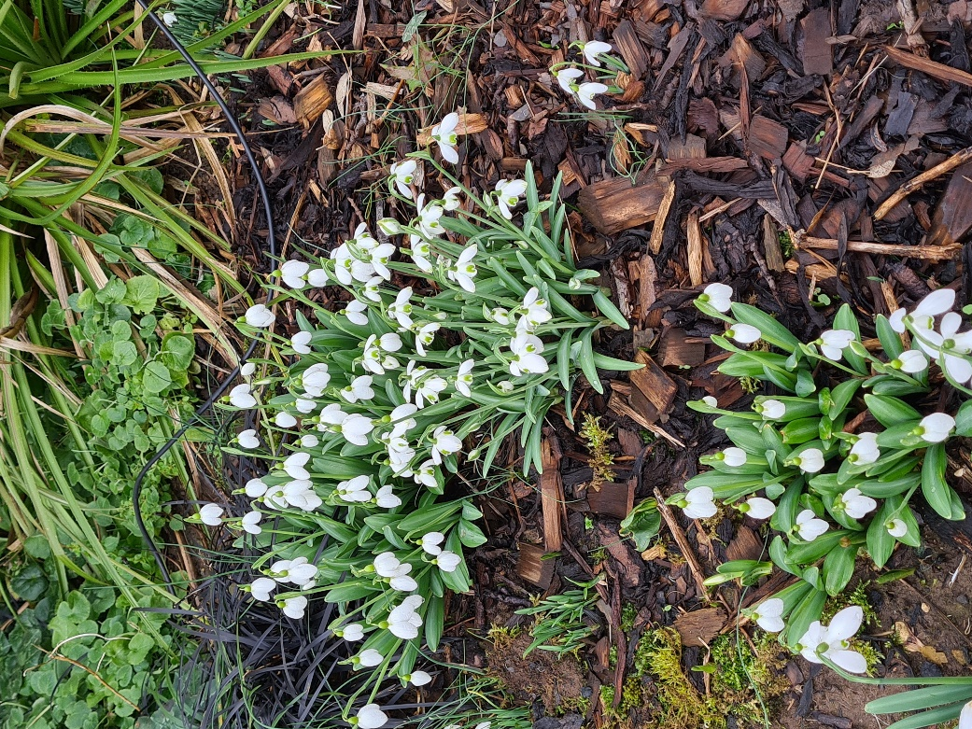
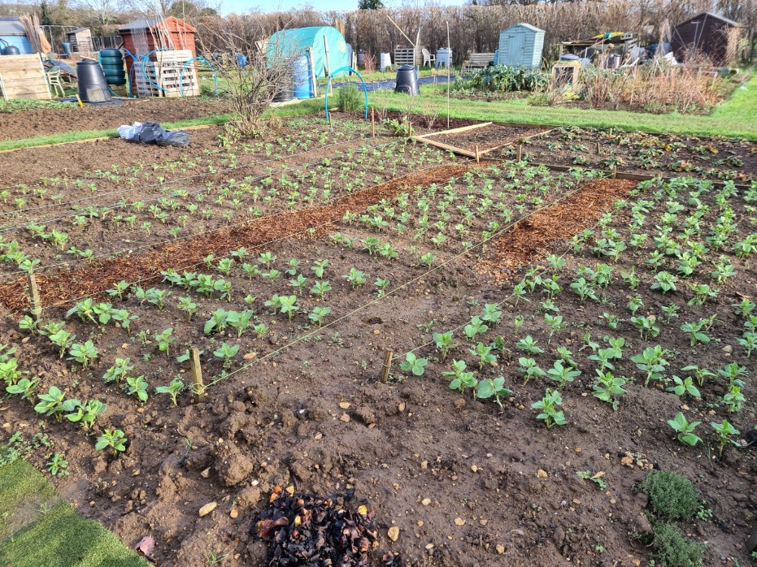
Just a few of the broad beans on the allotment!

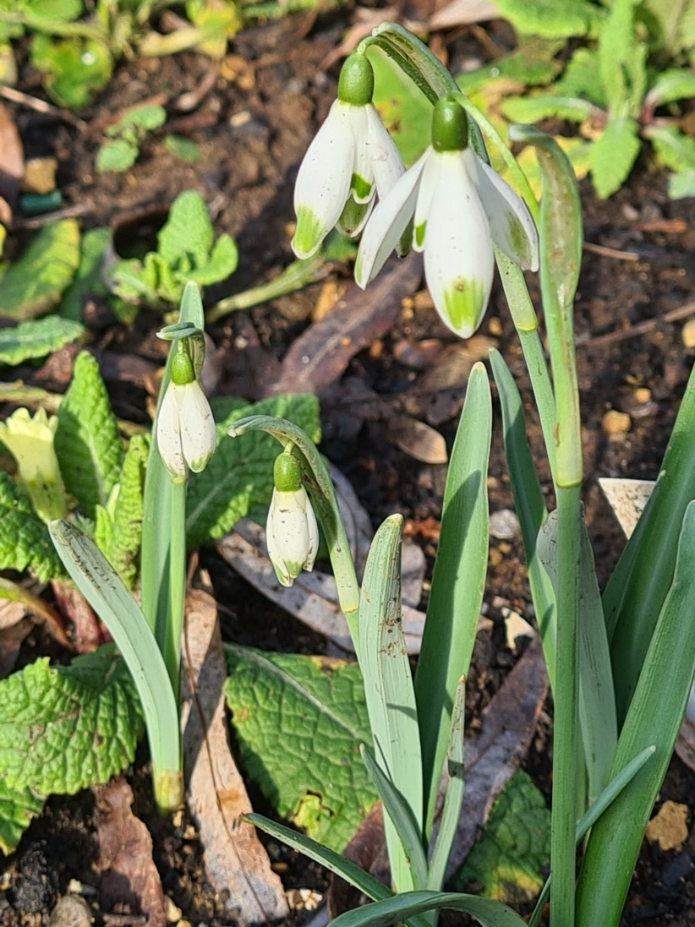

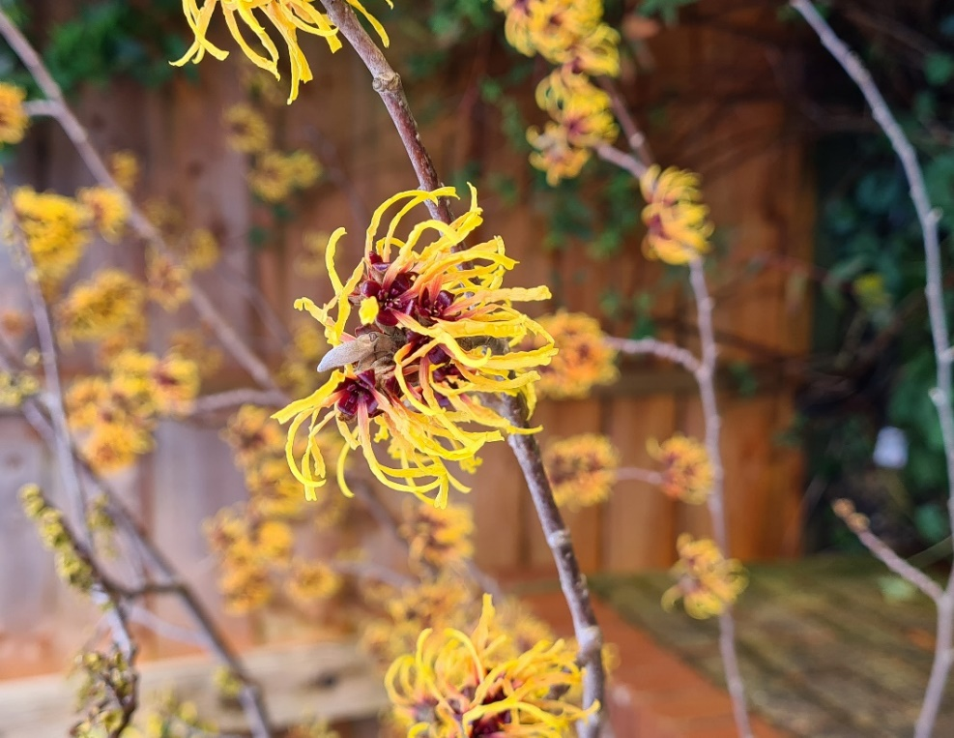
Snowdrops ‘Augustus’ & ‘Hippolyta’?

Snowdrop ‘Viridapice’
Hamamelis Mollis

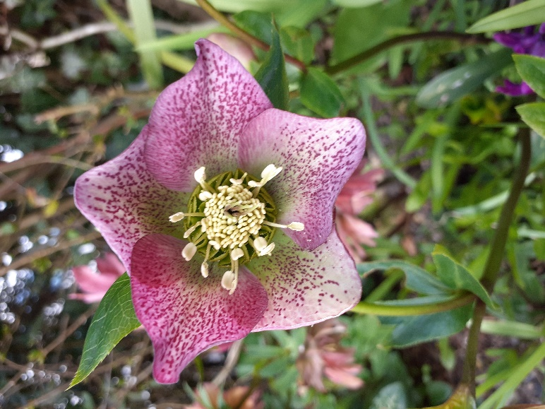
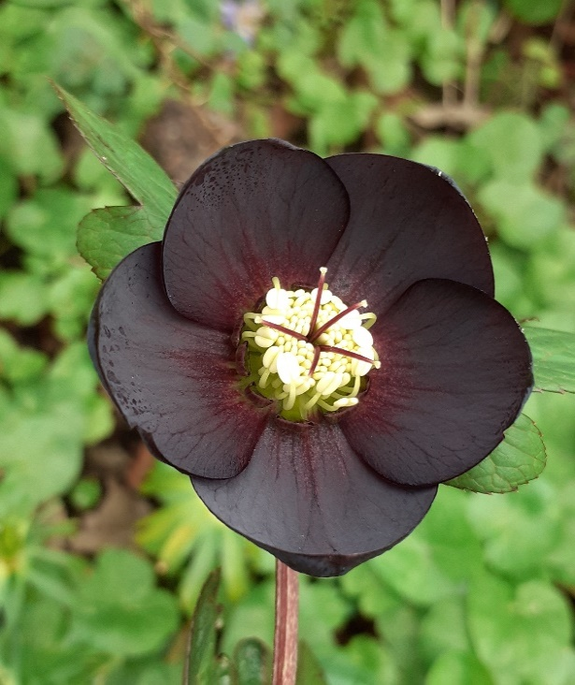
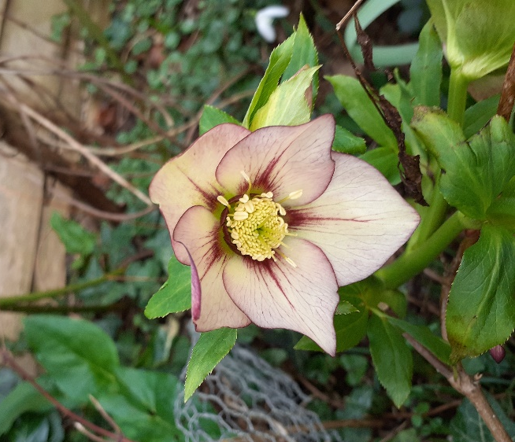
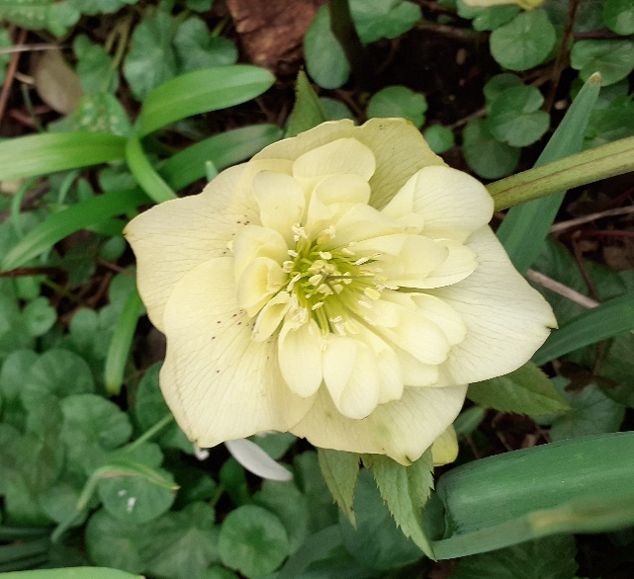
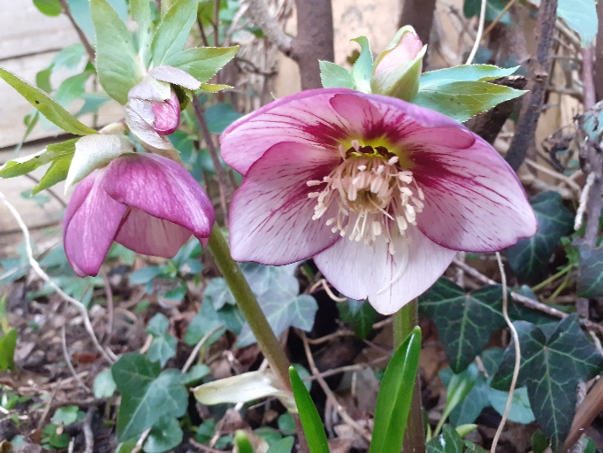
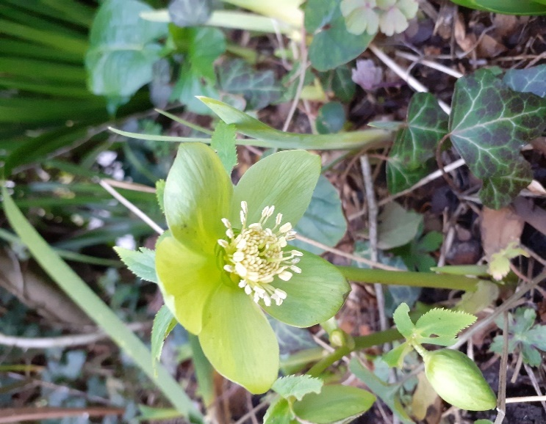
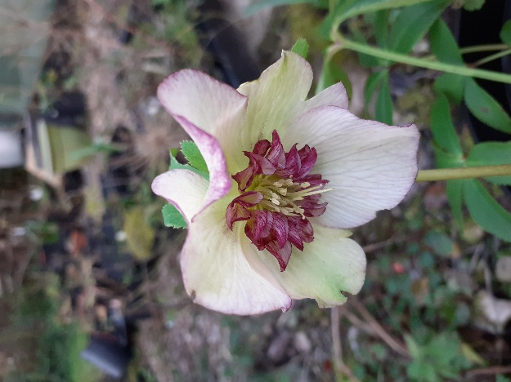
Some Hellebores
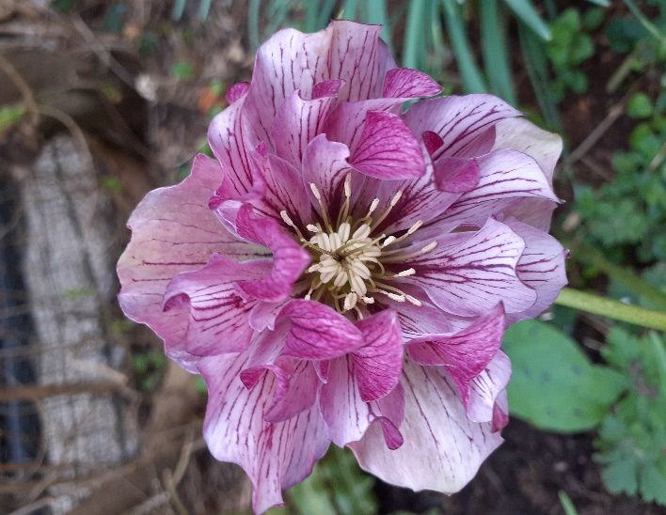
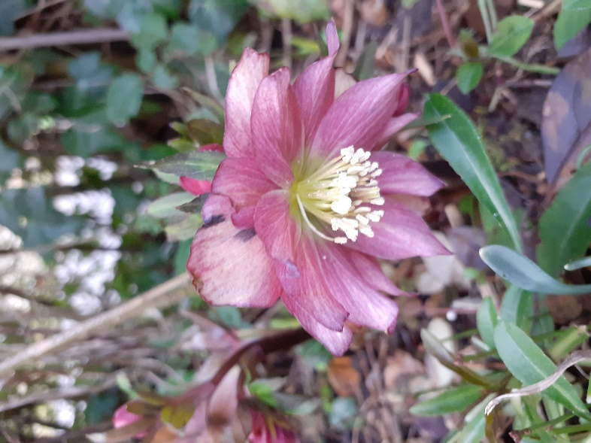
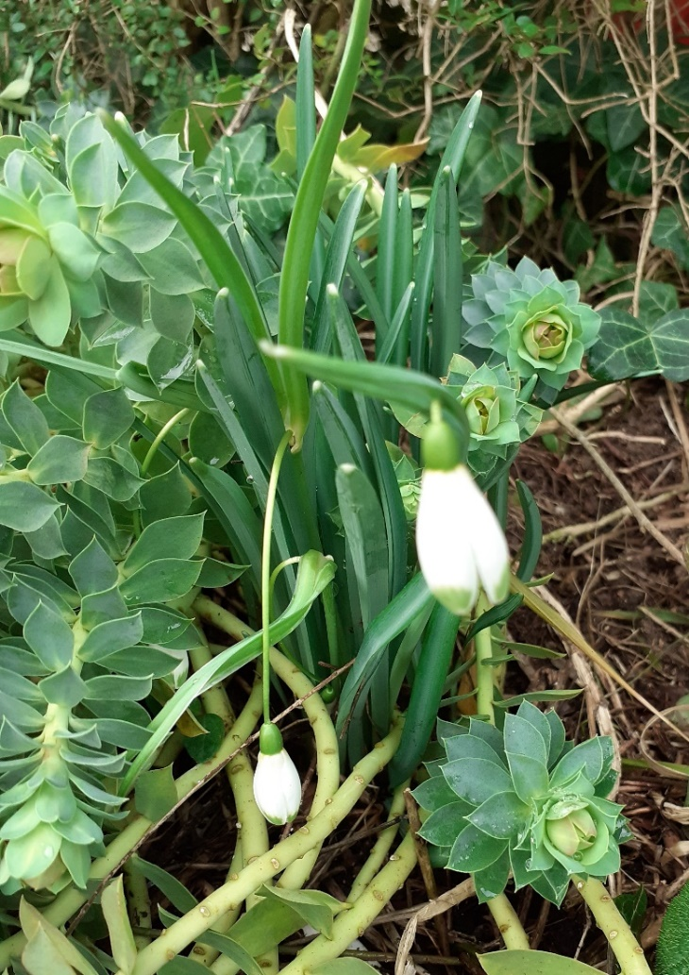
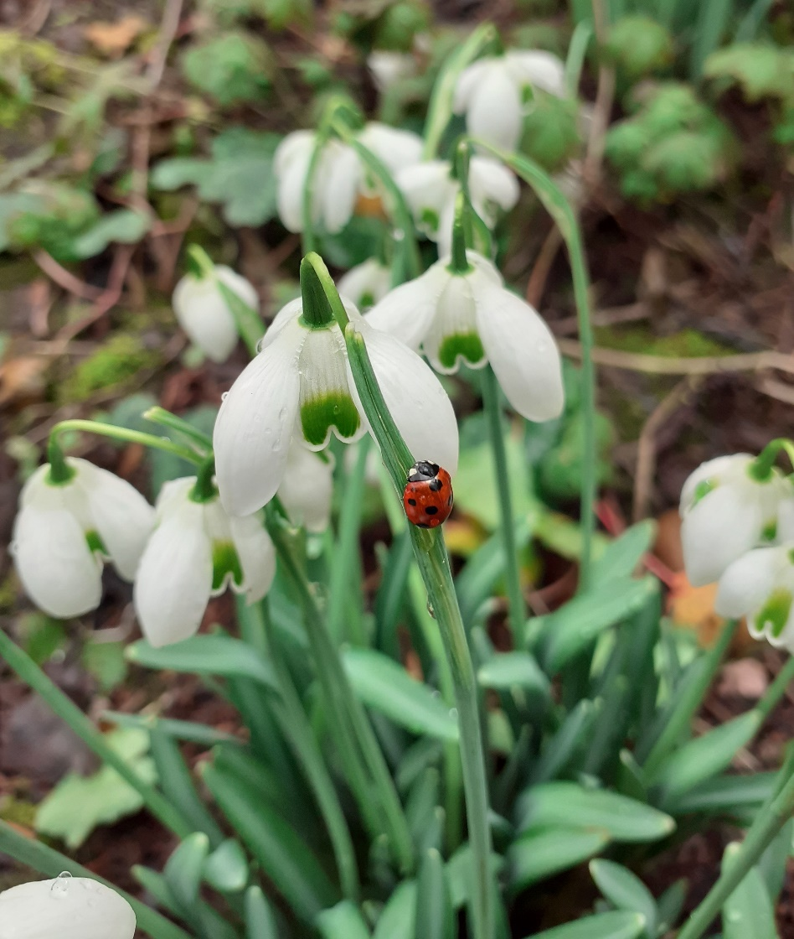
and some Snowdrops

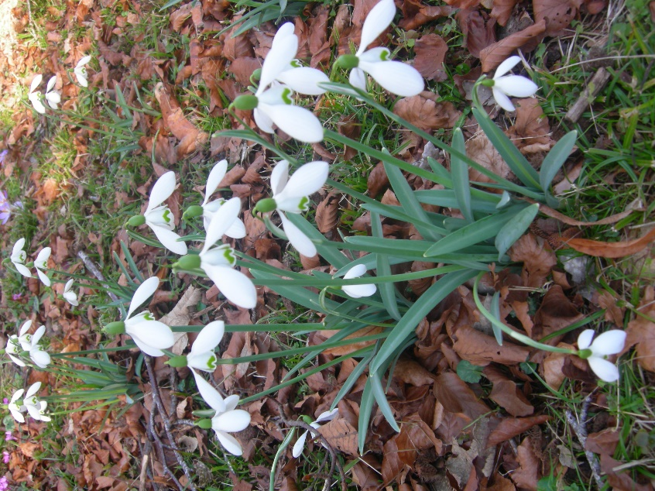
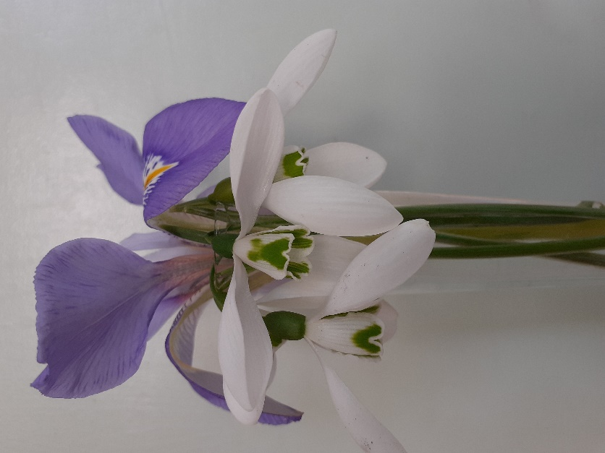

Trees

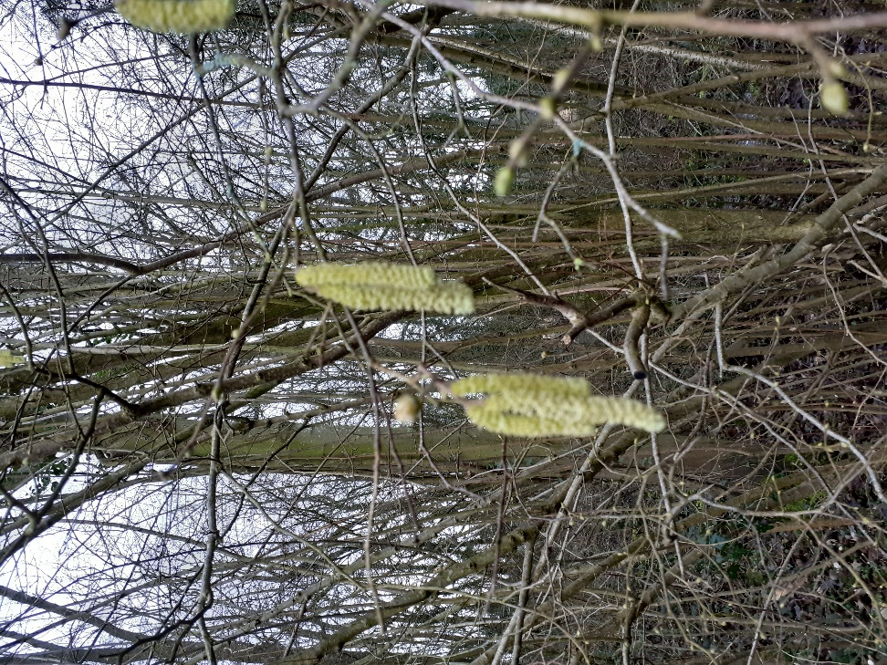
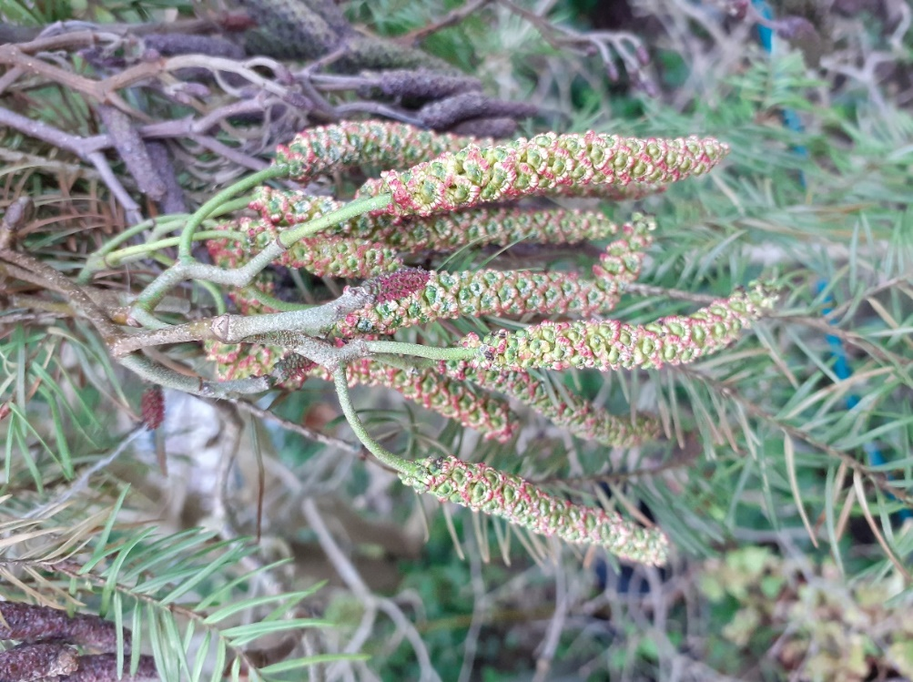

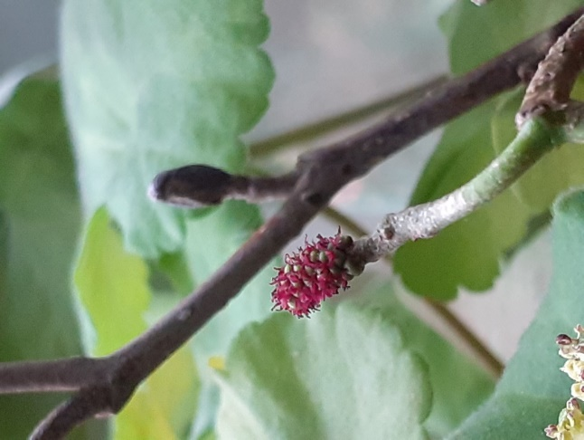
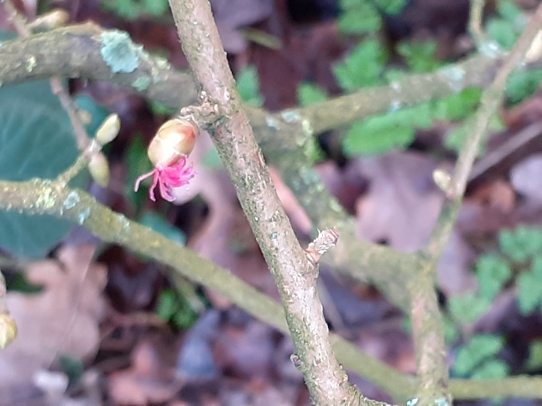

Hazel Catkins & Alder Catkins &
Female flower Female flower

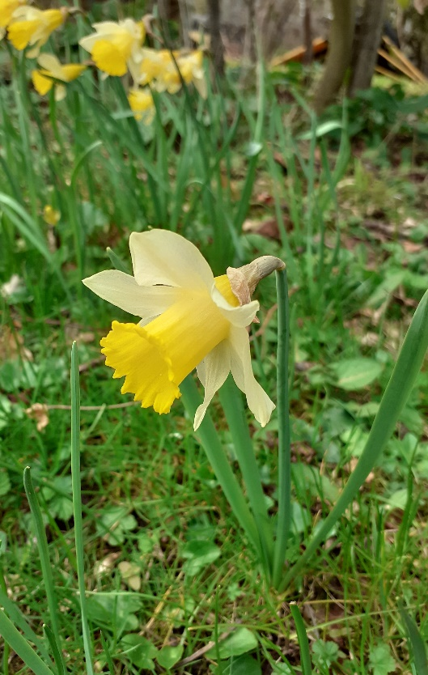
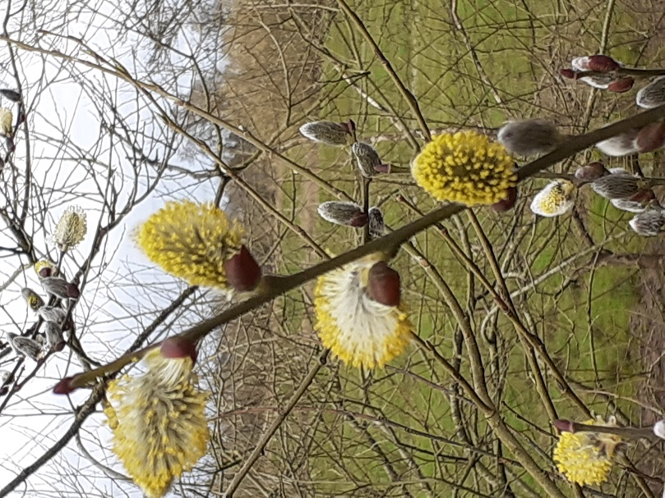
Willow catkins and wild daffodils at Over Canal basin

Brenda Jones’s Garden on May Hill

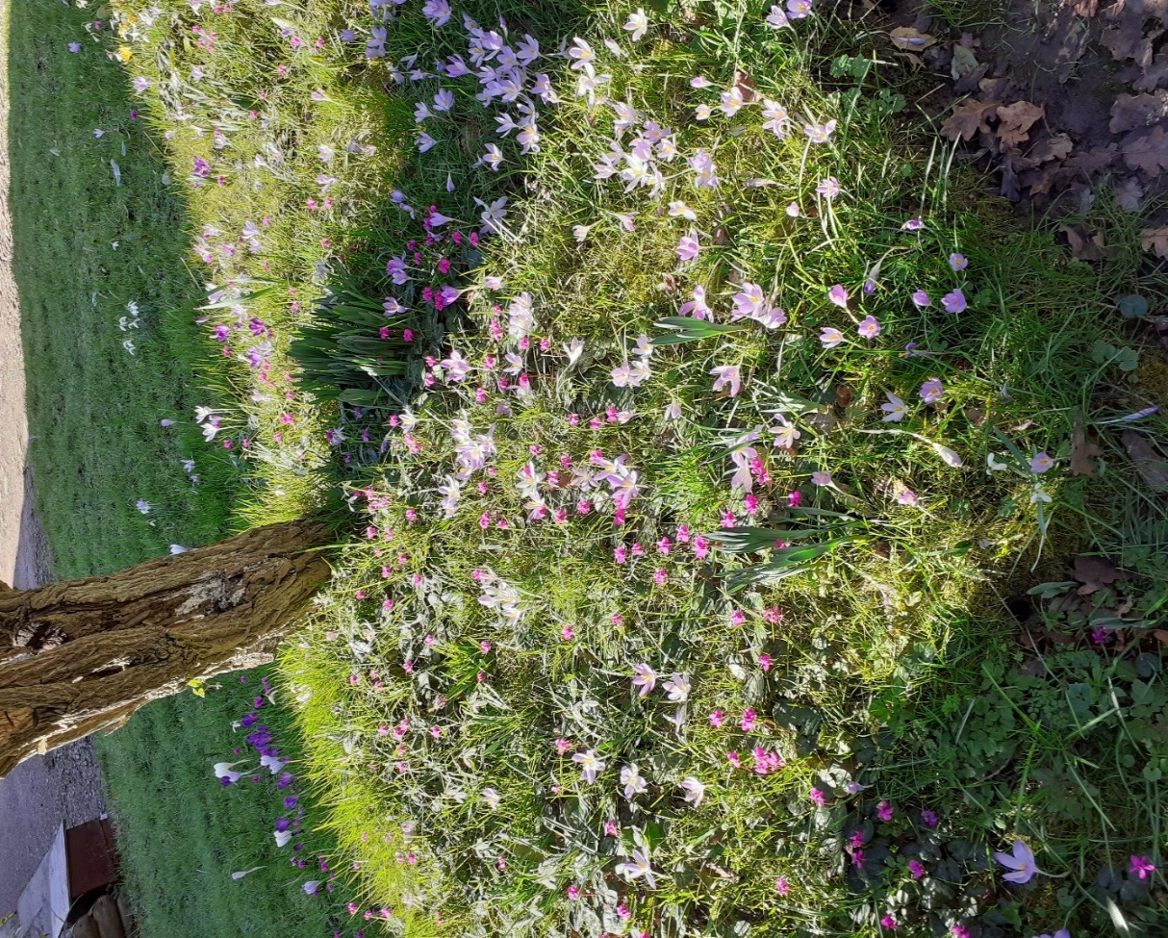
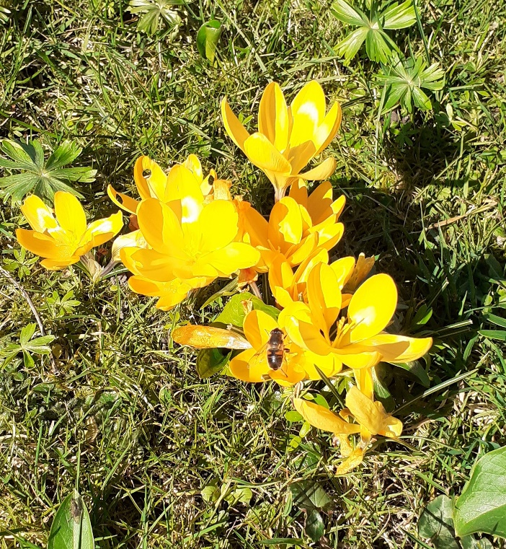

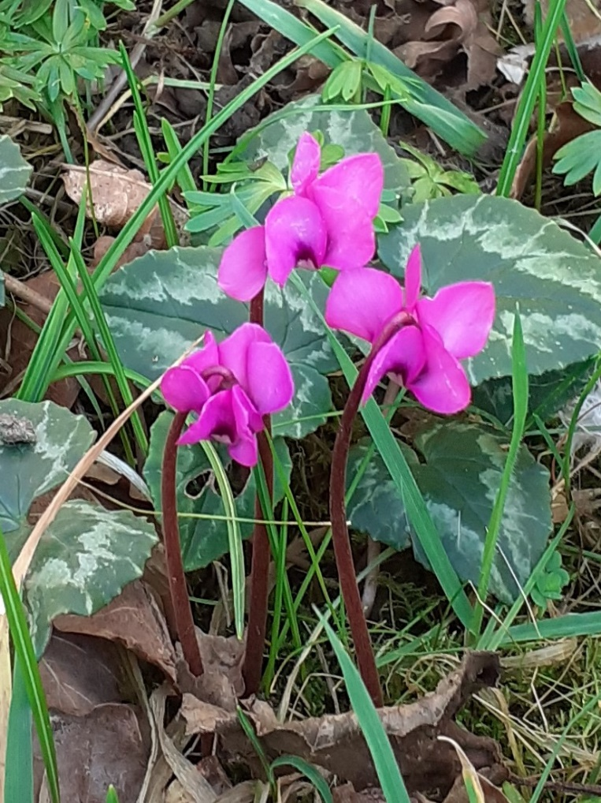
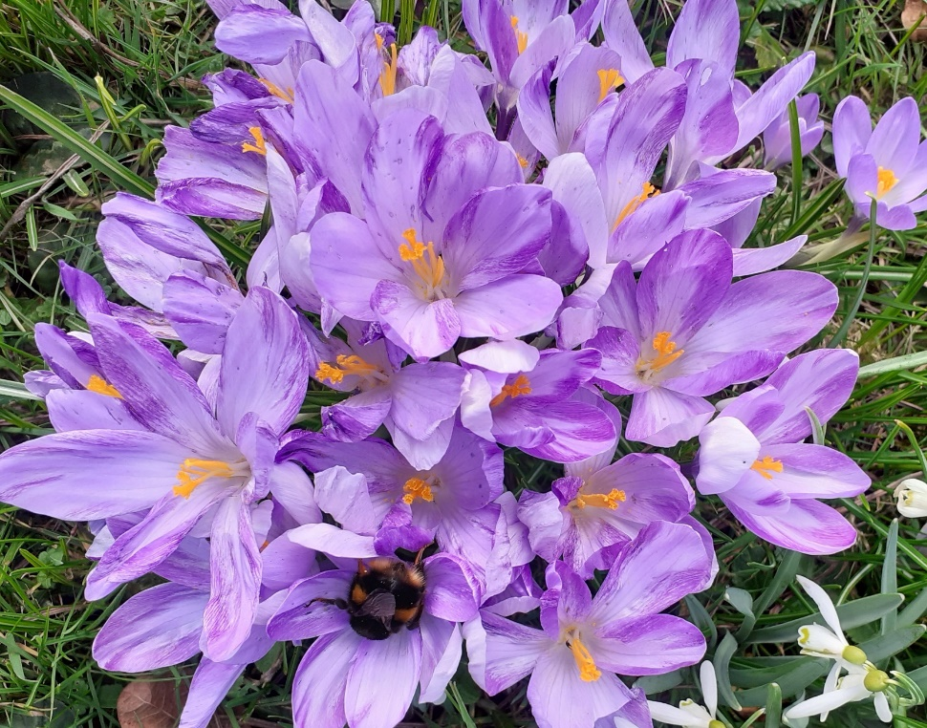
Crocus Thomasinianus & Cyclamen Coum

Cyclamen Coum
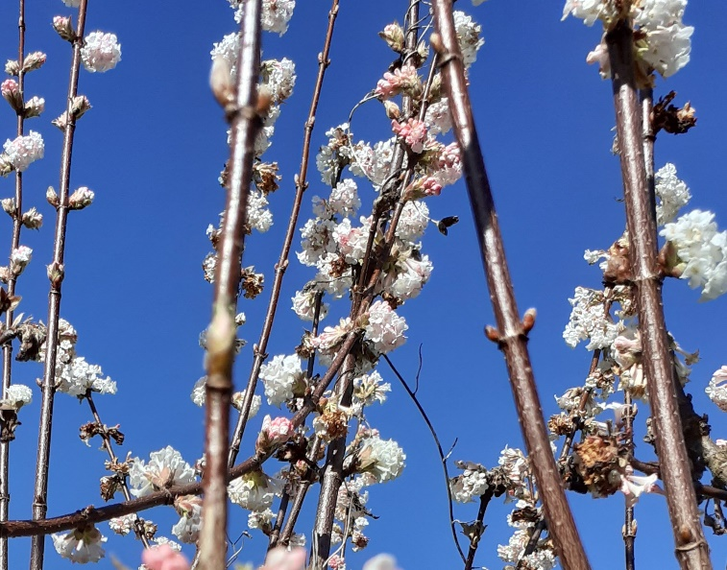
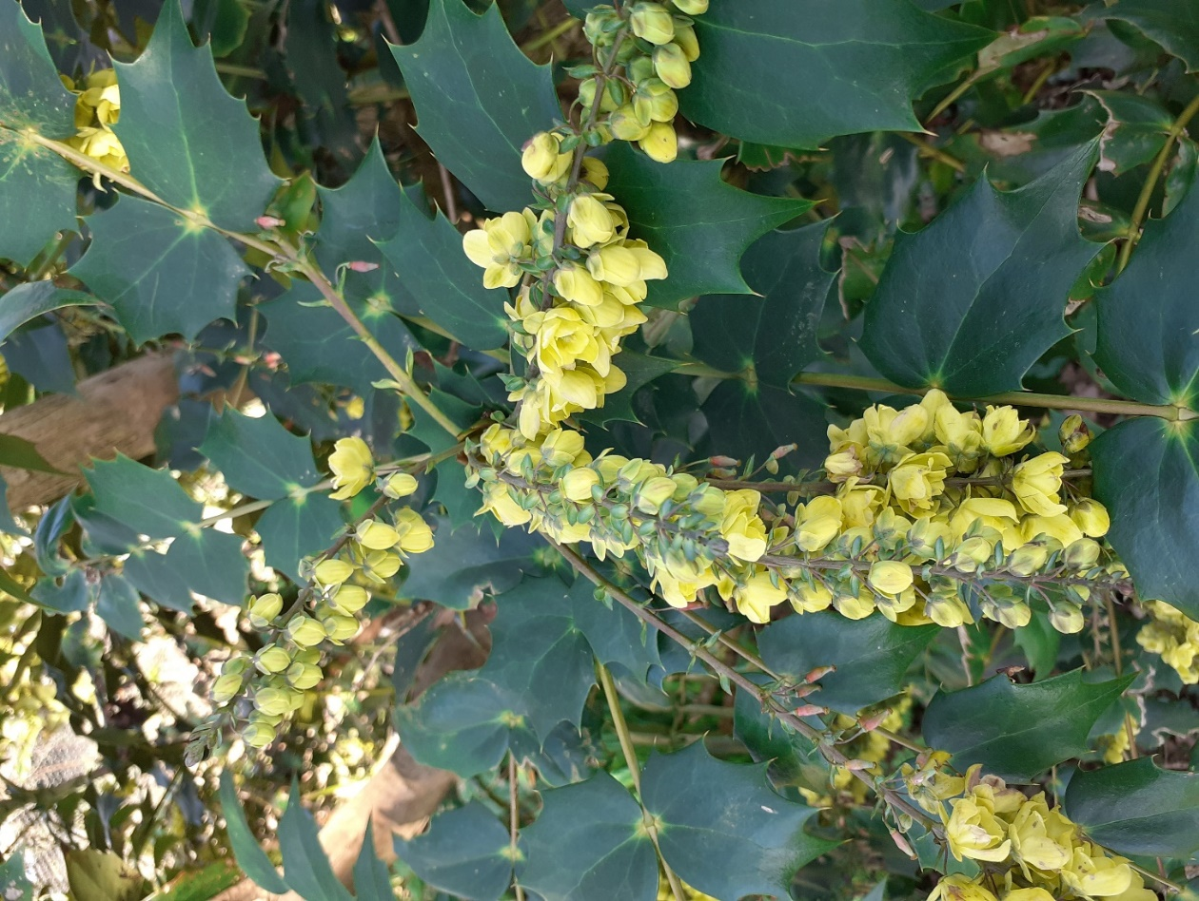
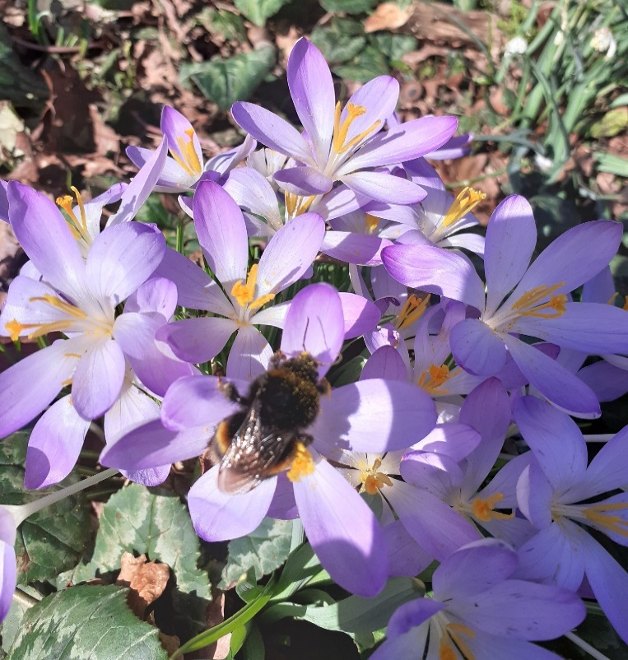
Viburnam
Mahonia
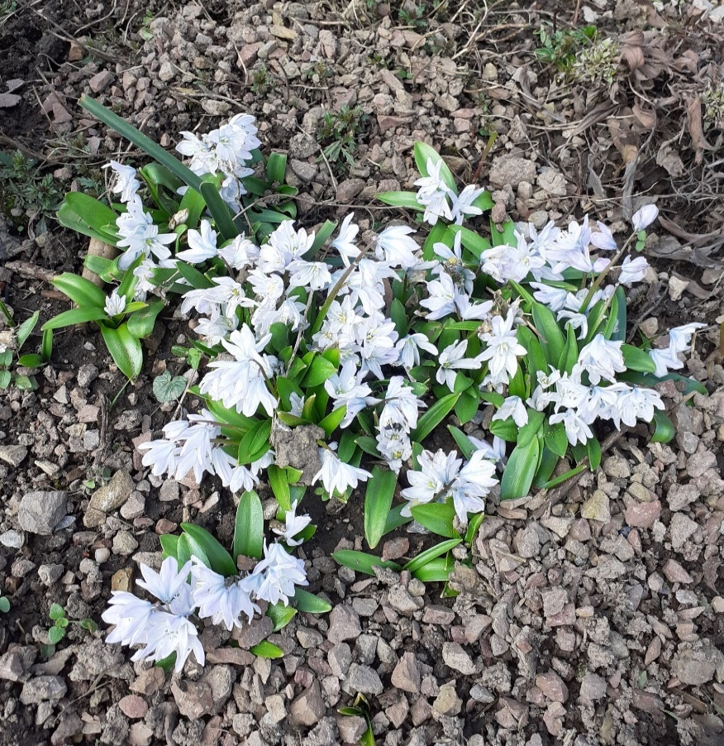

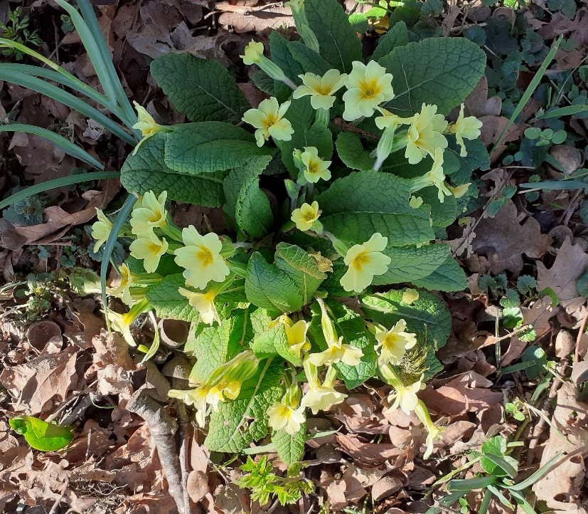
Crocus Thomasinianus
Puschkinia Primrose
Naturalising plants in a wild garden – Brenda Jones
Snowdrops & narcissus, especially wild daffodils, will naturalise easily but others need a bit more supervision:
Cyclamen Coum
Grow separately from cyclamen hederifolium as hederifolium are more vigorous and will
overwhelm it.
Leave undisturbed, around trees, shrubs, woodland but keep any grass mown or controlled
between June and July…?
Crocus Thomasinianus
The flowers are very frail and need to make a clump and have sun. It will seed everywhere
and sadly a lot of loners just get trodden on. A good clump have developed in the shelter of
established autumn cyclamen.
Puschkinia Scilloides
Hardy bulb. It’s name gives away it’s Russian origin, named after Count Mussin Puschkin. It is from the Caucasus and needs sun and good drainange. NOT FOR GROWING IN GRASS.

Brenda’s Wild Garden in spring with wild daffodils, that have spread into the field, and
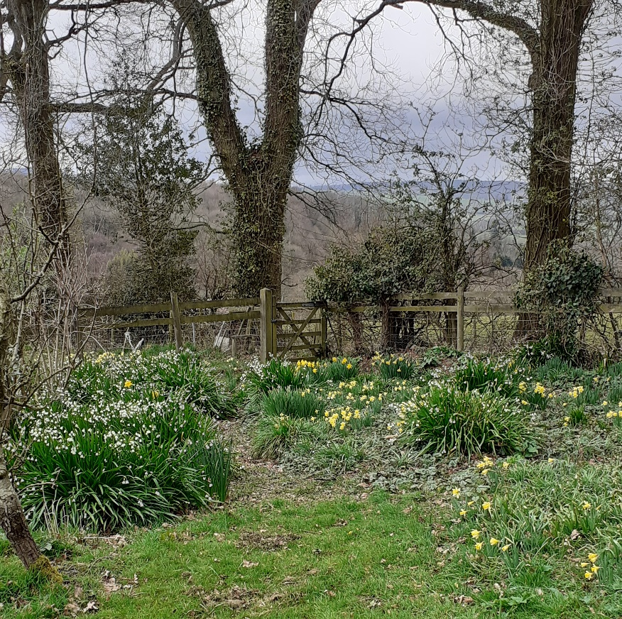
leucojum aestivum in abundance.
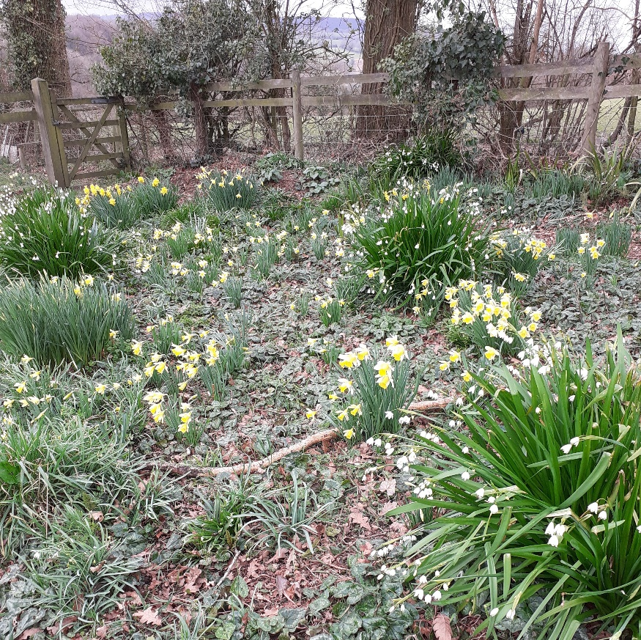
Snippet from Brenda
If you are laying membranes to smother weeds, a layer of wet newspaper underneath will encourage worms and stop the ground compacting.

POLENTA CAKE WITH RASPBERRIES
(GLUTEN FREE)

175g caster sugar
120 ml sunflower oil
115g gluten free SR flour
50g polenta
Juice of one lemon
2 tbs runny honey
3 med eggs
1 tsp baking powder – gluten free
Vanilla essence if liked
Raspberries (about 20)

1 7” x 11” tray bake tray
Bottom lined with
Silicon/greaseproof paper

Cream oil & sugar
Add eggs, vanilla essence, honey, lemon
Mix dry ingredients together &
add to the creamed mixture and beat well
Pour into prepared tray
Bake in the centre of the oven at
gas Mk 5, 190C for 15mins or so, and then at
gas Mk 4, 180C for another 20 - 25mins/ until firm to the touch.

Drop fresh raspberries into the mixture when the cake is starting to firm
(carefully pull out the oven shelf far enough to be able to add the raspberries quickly) ; the cake doesn’t seem to suffer any detriment from adding at this point and they stay on the surface, if added before baking they sink to the bottom of the cake, your choice.
Dust with icing sugar and cut into squares
Freezes well.

Useful self seeders

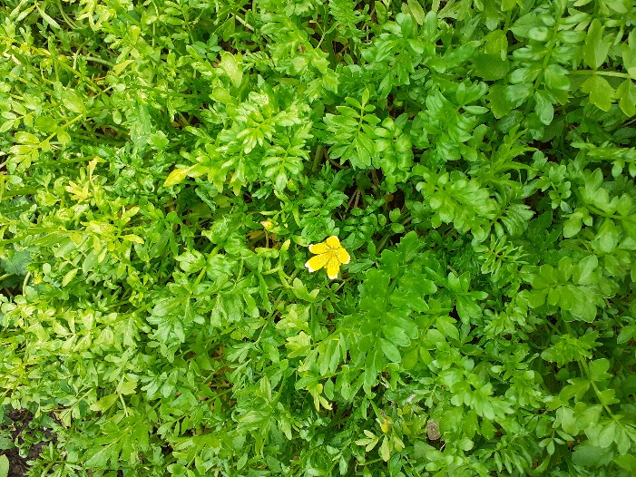
I know that some are not in favour of plants that are prolific self seeders but in general I don’t mind, they’re free plants to me .
A couple that I find really useful are poached egg plant and lamb’s lettuce.
I have a small bed (about 1ft) across one of my 4ft beds where I leave the poached egg plants to go to seed and the seed to fall and germinate and then I have a good patch for the following season to attract the beneficial insects.
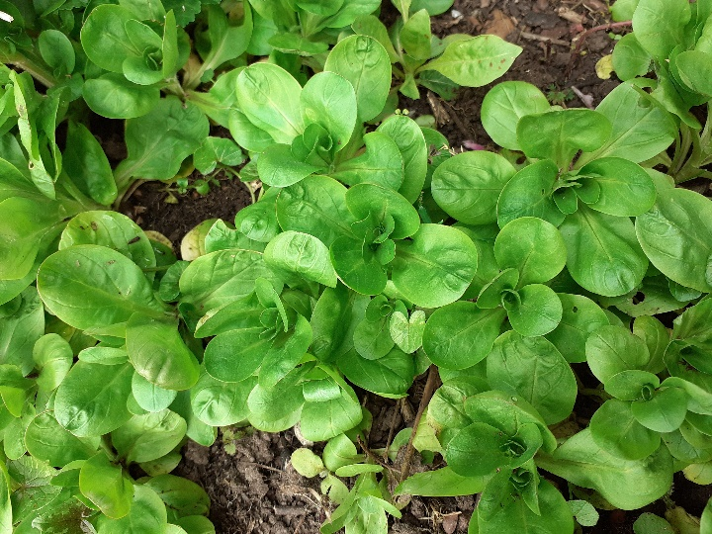
I find lamb’s lettuce quite difficult to germinate and so I leave a couple of plants to go to seed and then I have lots of leaves to harvest from February onwards.

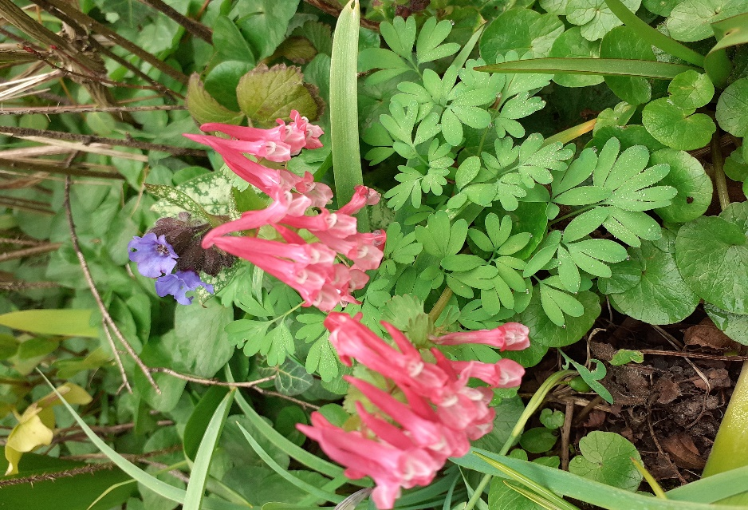
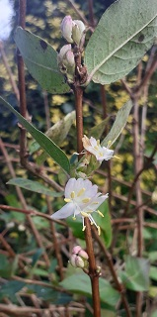
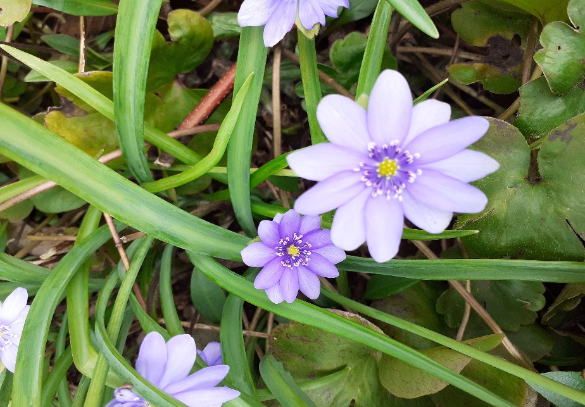
Late Winter/Spring Plants

Corydalis Beth Evans Hepatica Nobilis Winter Honeysuckle
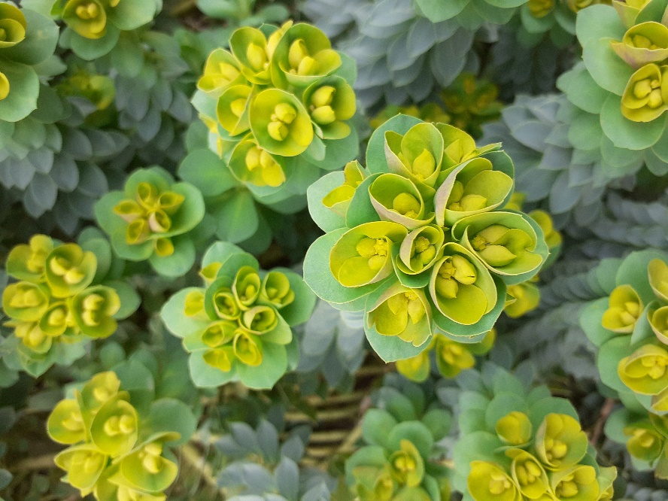
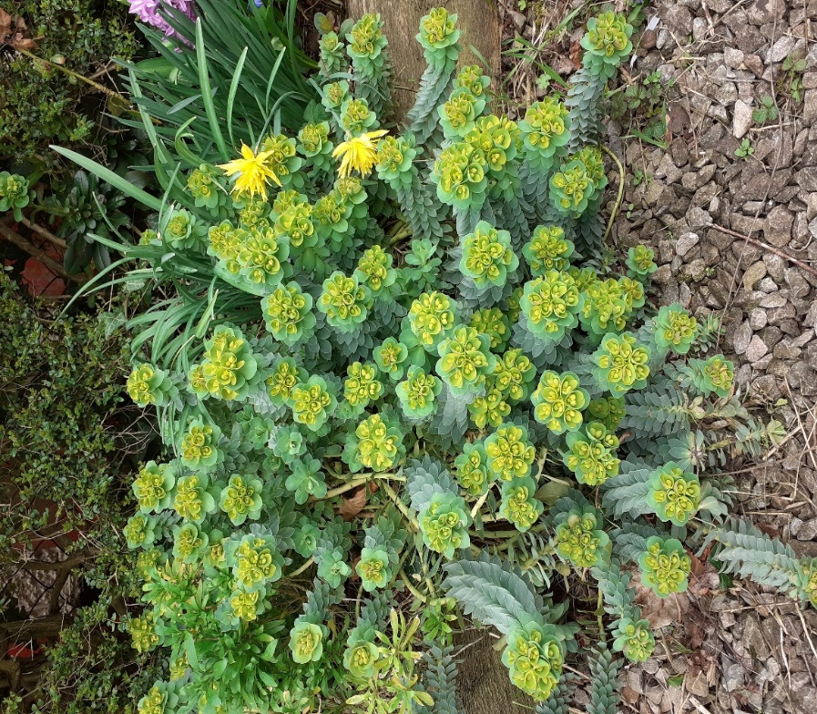
Euphorbia myrsinites

MANY THANKS TO ALL CONTRIBUTORS

